This is a restaurant management system. It is mainly consist of two parts. One is order system, the other is used for staff to manage restaurant.

The Abstract Basis Class is food class, this restaurant offers kinds of foods, include minidishes, snacks and drinks. But different kinds of food, needs different time to cook, which cost different labour cost.

Maindishes takes longest time, drinks take least time. So, they have different labour cost, which would influence our profit. We use vector collection to help us organized objects more flexibly.

Customers can order foods, which would be record in their cart. After finished order, they can choose to pay the dishes in their cart.

Staff can use this system to view the financial report. And edit restaurant menu.

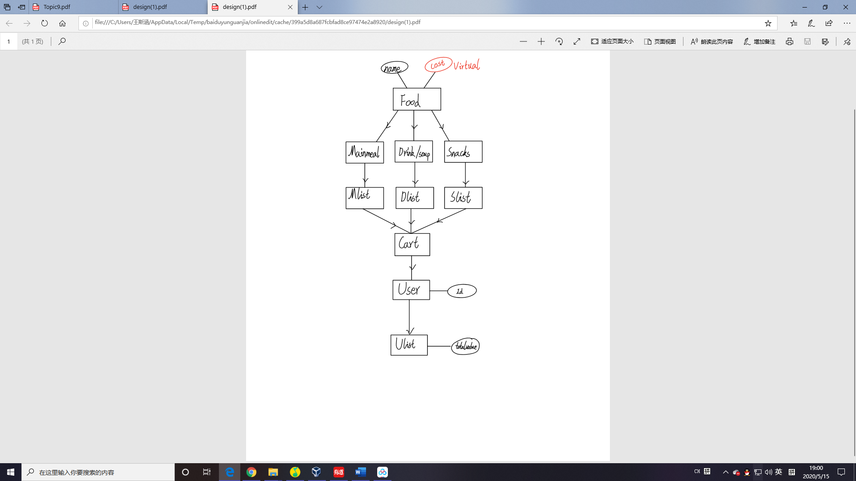Terminal User Interface is implemented in main.cpp. The other object function is implemented in other .h and .cpp document.